**Assessement – 4**

**Write SQL query to solve the problem given below.**

**There given a table named as product**

**The products are the computer components like keyboard, motherboard, monitor ,**

**speaker, etc..**

**The product table contains attributes like product id, product name, price and product code.**

**Ans.** **CREATE TABLE product (Pro_ID INTEGER PRIMARY KEY AUTOINCREMENT, Pro_Name TEXT, Pro_Price REAL, Pro_Code INTEGER);**

**INSERT INTO product (Pro_Name, Pro_Price, Pro_Code)VALUES**

**("Mother Board", 3200, 15);**

**("Key Board", 450, 16), ("ZIP drive", 250, 14), ("Speaker", 550, 16), ("Moniter", 5000, 11), ("DVD Drive", 900, 12), ("CD Drive", 800, 12), ("Printer", 2600, 13), ("Refill Cartidge", 350, 13), ("Mouse", 250, 12);**

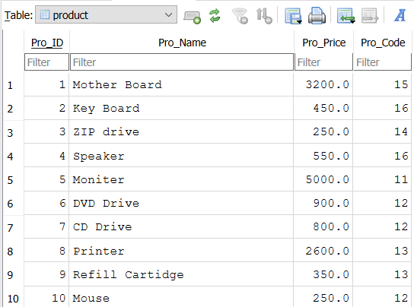

* **Write sql query to find the items whose prices are higher than or equal 250rs. Order the result by product price in descending, then product name in ascending. Return pro_name and pro_price**

**Ans. SELECT PRO_NAME, PRO_PRICE FROM product WHERE PRO_PRICE >= 250 ORDER BY PRO_PRICE DESC, PRO_NAME ASC;**

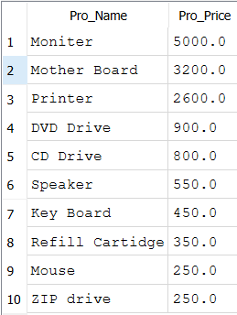

* **Write a sql query to find the cheapest item. Return pro_name and pro_price.**

**Ans.**

**SELECT PRO_NAME, PRO_PRICE FROM product ORDER BY PRO_PRICE ASC LIMIT 1;**

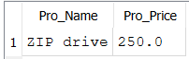

* **Write the sql query to calculate the average price of the items for each company. Return average price and company code.**

**Ans.**

**SELECT Pro_Code, AVG(PRO_PRICE) AS AVG_PRICE FROM product GROUP BY Pro_Code;**

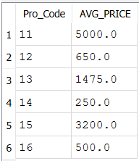

* **Write the sql query to find the average total for all the product mention in the table**

**Ans.**

**SELECT AVG(PRO_PRICE) AS AVG_TOTAL FROM product;**

